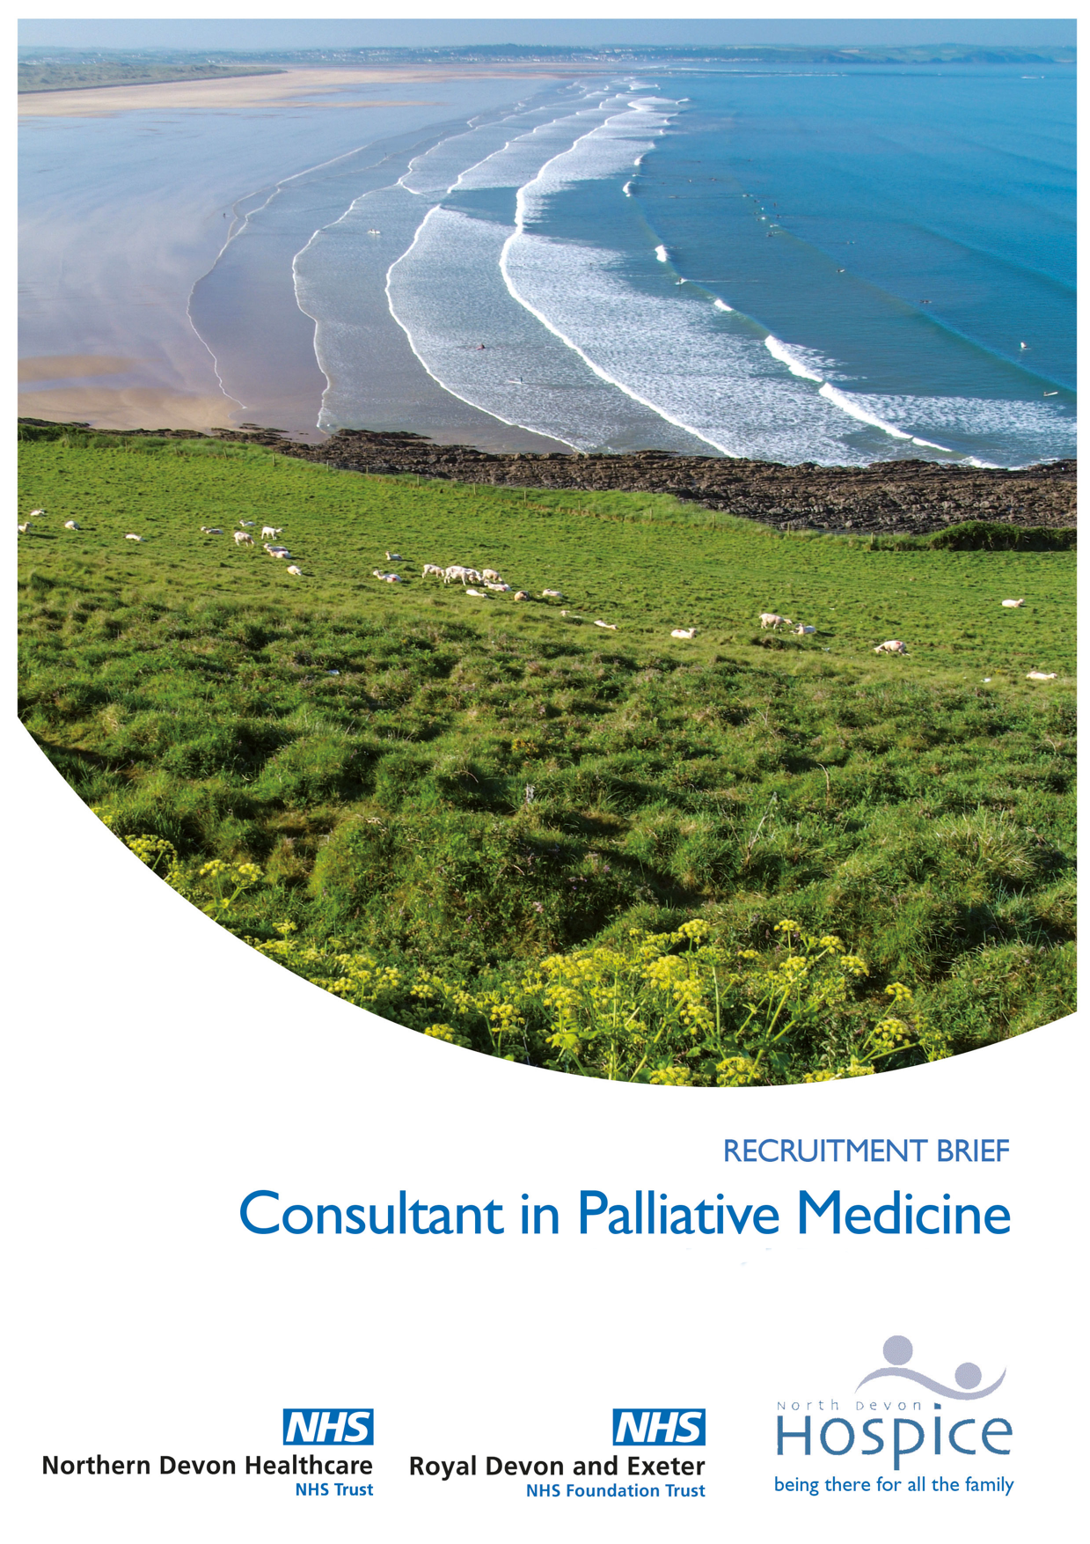
Welcome
Our patients are at the heart of every single thing we do. Following retirement of a long-serving post-holder, we are seeking a new Consultant in Palliative Medicine, to work 8 PA’s alongside the Trust’s existing Consultant in Palliative Medicine. We are committed to flexible working arrangements, including job sharing and we will discuss these arrangements with any shortlisted candidates.
Our county is frequently rated as one of the best places to live in the UK, and offers a fantastic mix of cultural and outdoor activities. You will be based at North Devon Hospice. In addition to responsibilities in our 7-bedded inpatient unit, you will also have sessions supporting the hospital and community palliative care teams. As well as enjoying the benefits of being employed by Northern Devon Healthcare Trust (NDHT), you would be a key member of the hospice’s management team, serving as its medical lead. In addition, the role is supported by the regional network of Palliative Medicine Consultants, such as those based at Royal Devon and Exeter Hospital with whom NDHT has a formal collaboration.
Through the passion of over 160 staff and over 500 volunteers, last year North Devon Hospice achieved outstanding care for nearly 3,000 people. Whether in one of our 7 beds on our bedded unit in Barnstaple, through one of the 4,900 visits carried out by our community nurse specialists, one of the 6,406 hours spent with patients in their home by our Hospice to Home team or as one of the 300 people cared for at our outreach centre in Holsworthy called The Long House, we believe, very simply, that the patient comes first.
You will play a key role in the development of a fully integrated Palliative Care Service for North Devon and support the health community to deliver the End of Life Strategy. The post holder will work closely with the Consultant in Palliative Medicine based at North Devon District Hospital and the Consultants will provide cross-cover. With the hospice now providing an “in-reach” service onto the wards of NDDH in a unique and truly integrated care model this is a great opportunity to further enhance joint working of existing services across acute, community and hospice settings. The job plans of the Consultants are structured to ensure that both Consultants have the opportunity to practise clinically across all care settings. In addition, an essential part of this role is involvement in a wide range of educational initiatives to enhance the care delivered by health and social care professionals in all sectors.
“When I first went there I thought a celebrity had walked in but they were speaking to me”
A patient

Looking forward, it is an exciting time to join the Hospice as you will be working with us to help develop our new 5 year strategic plan, designing what our care model will look like from 2020. If you would enjoy working in a truly integrated care model across the hospice, hospital and in the community as well as delivering education to our healthcare partners then please do get in touch. We believe in “being there for all the family”, would you like to “be there” too?
Best Wishes,
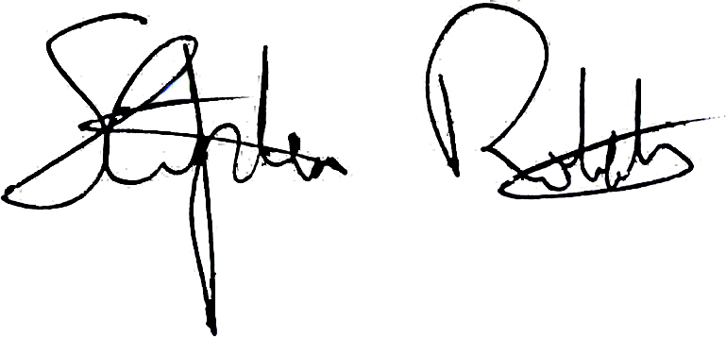
Stephen Roberts, CEO

Catchment Map
Supporting the local North Devon population of 168,000 people, North Devon Hospice’s aim is to provide the highest possible quality end of life care and support to patients and their loved ones in any setting across the 800sq.miles of North Devon.

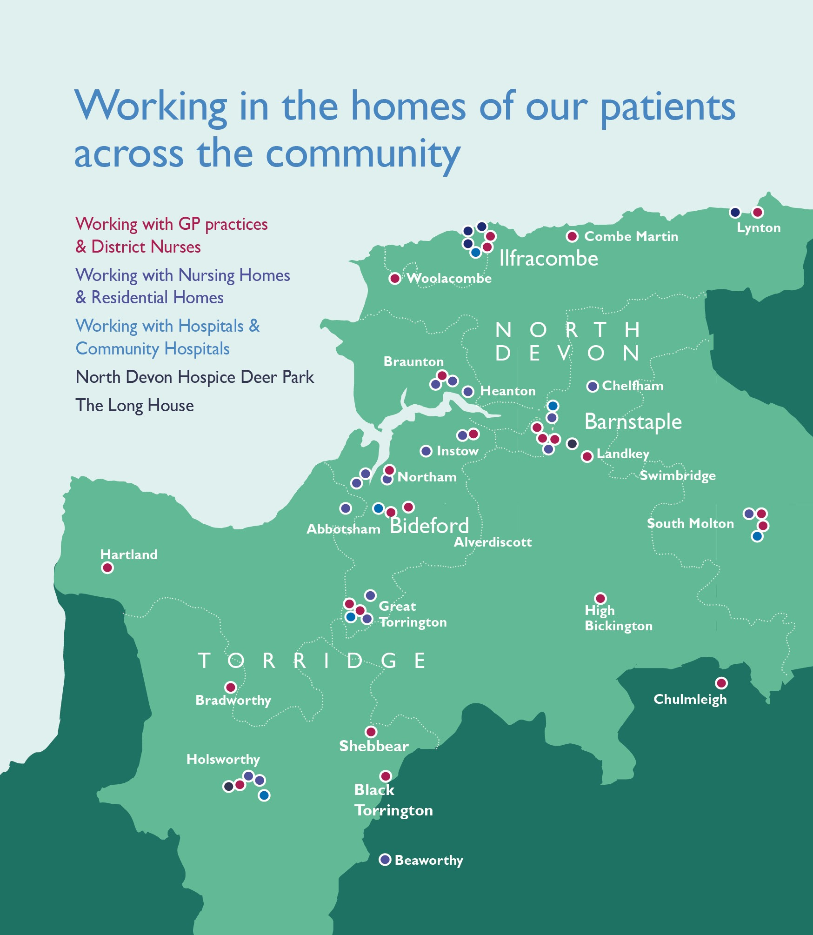

North Devon Hospice

We provide specialist care to over 2,000 patients and their families each year who are facing life-limiting illnesses from across North Devon. We respond to all clinical referrals within 24 hours.

Most of our patients are cared for in the comfort of their own homes through both our Clinical Nurse Specialists and Hospice to Home team.

Clinical Nurse Specialists: A team of 11 who provide specialist palliative care community nursing for adult patients, who have a progressive terminal illness both cancer and non-cancer or are on the Gold Standards Framework Register and would benefit from symptom management, psychological assistance and holistic care with emotional and spiritual needs.

Last year the team looked after over 1,568 patients and carers made nearly 5,000 visits covering over 50,000 miles in the process. The team work in hours Monday to Friday.

Hospice to Home Service: The team of multi-skilled healthcare assistants and clinical nurse specialists provide hands on end of life care in your own home to enable you to stay at home if this is your preference. The support provided can be a short-term intervention to help prevent a crisis from escalating or to avoid an acute admission. The service is available to patients who are identified as being in the last 3 months of life and is provided around the clock.

The team looked after nearly 400 people in their own home last year and directly contributed to over 250 avoided hospital admissions.

Bedded Unit: We provide specialist palliative inpatient care for adults with complex problems associated with advanced progressive illnesses. This support is available to patients who have complex end of life care needs and require treatment for pain management or other distressing symptoms.

We give this care 24 hours a day, 365 days a year, however it is not a long stay unit. Care is provided through a seven single rooms bedded unit. We have a high nurse to patient ratio, allowing us the opportunity to give dedicated support to patients with a variety of symptoms associated with a life-limiting illness.

Around 60% of our patients are discharged after a short stay with us. With the unit looking after approximately 170 patients per annum.

Supportive Care: We provide a range of supportive care services to patients and pre and post bereavement support to carers and family members, including children. Supportive Care services can be accessed at our main hospice site at Deer Park in Barnstaple or our outreach centre, The Long House, in Holsworthy. Last year over 1,200 people accessed this support.

Education: Our Education team supports our own clinical staff with training needs as well as other healthcare professionals, GPs and healthcare students across North Devon. They help to develop skills and confidence in working with people facing life-limiting illnesses.

Ambitions for our Care & Education

We are about to commence a number of major developments which act as a national “flag bearer” for how effective integrated end of life care should be. These include:

- Embedding the new integrated care model with secondary care, specifically Northern Devon Healthcare Trust (NDHT).
- Formal Partnership working with the local Rapid Intervention Centre at the Hospital.
- Working with Commissioners to review the potential for an End of Life Care co-ordination hub for the North Devon.
- Working with Commissioners and the Devon wide STP to develop and enhance:
  - Advance Care Planning
  - Treatment Escalation Plans
  - Enhanced use and design of the end of life care register used across Devon.
- Maximise the care provided to those patients with Continued Healthcare funding. We won the tender to provide end of life care to this cohort of patients via the Devon Cares contract run by NDHT.
- Develop further our volunteer base supporting carers and patients in their own home.
- To develop our internal clinical education programme and continue our clinical education provision to our healthcare partners.
- Develop the career pathway from HCA to RN and develop further nurse prescribing.
- Work in partnership with the local Care Academy and Medical Schools to support work based placements for healthcare and medical students.
- Oversee our plans to move to a new patient database SystmOne (currently on Crosscare), in so doing bring us into line with our GP colleagues across North Devon.

Essentially we want to ensure that both now and for the future that our care and education is always evolving to meet the future needs of our patients and their loved ones. In so doing ensure that North Devon Hospice is seen as a national flag bearer on what excellent end of life care looks like both by the hospice movement as well as the wider healthcare community.
“What I really got from the experience is a gold-standard example of how medicine should be practised and how clinical teams should work together”
Medical Student

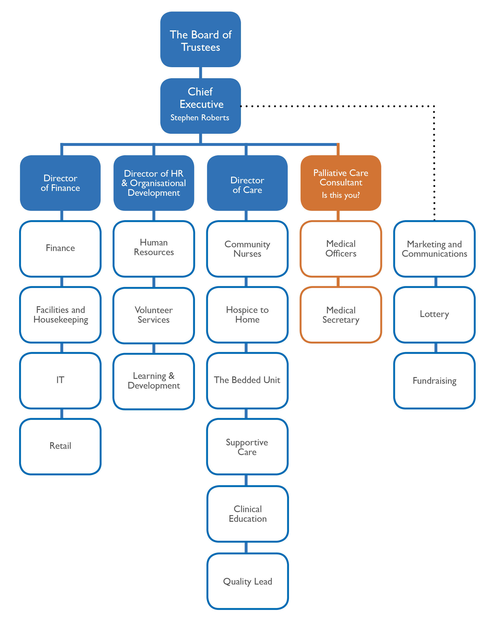
Organisation Chart

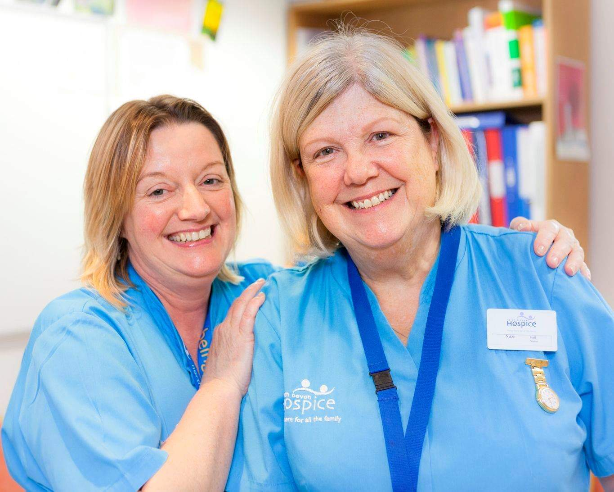

North Devon Hospice Senior Management Team
Chief Executive, Stephen Roberts
Stephen, our Chief Executive, has overall accountability to the Board of Trustees and for all hospice operations. Stephen has worked with North Devon Hospice for over 7 years, initially as the Commercial Director and, for the last 4 years, as the Chief Executive. Stephen also holds responsibility for our Lottery, Fundraising, and Marketing and Communications teams. Following a 15 year career in the City of London, he has extensive commercial/corporate and strategic risk management experience gained at Marsh & McLennan. Stephen is also on the board of Hospice UK.
Director of Finance, Samantha Husband
Samantha Husband has responsibility for Finance, IT, Facilities and Retail. Samantha has worked at the hospice for over 14 years and, prior to this, gained extensive experience in the private sector. Samantha is also a Trustee of the Charity Finance Group.
Director of Human Resources and Organisational Development, Cate Oliver
Cate Oliver joined us in September 2017 having held senior directorial and consultancy positions in the NHS, Private and Public sector. A top priority we are working on at the moment is rolling out a tangible staff wellbeing programme, leadership and management development, staff competencies and a new reward and recognition programme.

Director of Care, Jo Dedes
Jo Dedes joined us in August 2019 having previously been the Director of Care at St.Luke’s Hospice in Harrow & Brent, London. Jo has had a very successful career in palliative care including roles in acute trusts, commissioning and indeed started out life as a community CNS in palliative medicine. Jo is responsible for all aspects of care, leading our Bedded Unit, Community Nurse Specialists, Hospice to Home, Clinical Education and Supportive Care teams.

Palliative Care Consultant, Is this you?

“Somewhere in the sky there is a “Star” it radiates a haven of serenity, kindness, dignity, love, caring, assurance and peace. On this earth there is a mirror image of that star it is called “North Devon Hospice”.
A patient’s family member

Awards & Achievements

Hospice UK Innovation for Income Generation 2018

North Devon Hospice won this award for developing our own North Devon Monopoly board which generated a net profit of over £65k

Hospice UK Highly Commended for UK Team of the Year CNS 2018

The Community Clinical Nurse Specialist team were recognised for their incredible efforts in going above and beyond to reach patients during the snow blizzards in February 2018.

Third Sector Awards 2017 – Finalist for Impact Report
Recognising the innovative and engaging way that we presented our annual Impact Report using a fictitious cartoon character called Bob. The Impact report then followed Bob and his family through his hospice journey to death. It enabled us to showcase the breadth of hospice care to Bob and his family including children in a more engaging way.

Charity Times Awards 2014 - UK Charity of the Year
Our outstanding care was recognised at a national level, with praise directed specifically towards our contribution in developing and providing the new Hospice to Home service.

Nursing Times Awards 2012 - Cancer Nurse of the Year
Mary Brooks was a Specialist Community Nurse with North Devon Hospice for 22 years. She was well known as an outstanding nurse and was held in high regard by her fellow healthcare professionals. Mary was nominated not just for the longevity but the quality of her work.

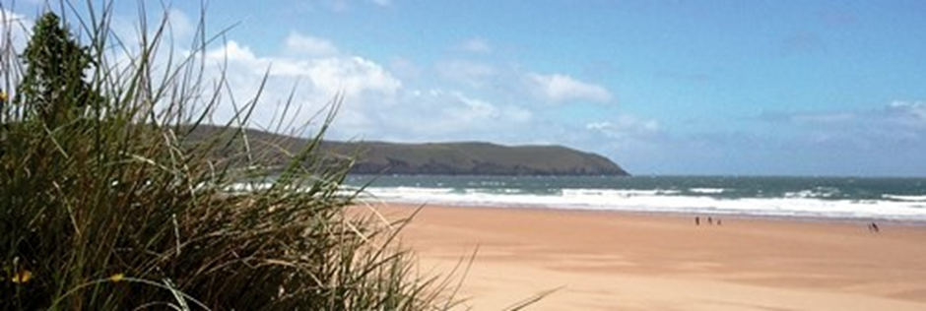

About North Devon District Hospital

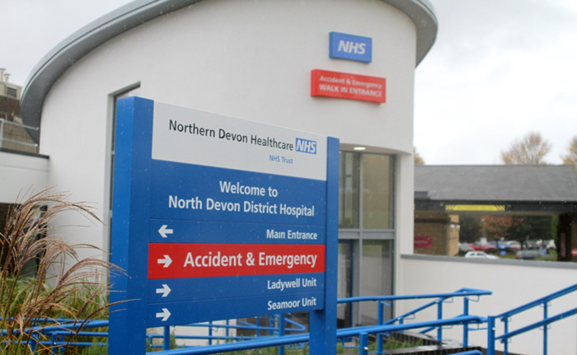

Northern Devon Healthcare NHS Trust operates acute and community services across North Devon, including the more urban areas of Barnstaple and Bideford and a more rural population throughout the region. The Trust also cares for patients from neighbouring areas in Cornwall and Somerset and there is a significant increase in activity in the summer months, as visitors to the area access emergency services.

NDHT provides a full range of acute services and integrated health and social care services in northern Devon, with 3000 staff serving a population of 165,000. It is expected that the population will rise to 186,000 by 2030.

The Trust’s vision
Delivering high-quality and sustainable services that support your health and wellbeing.

Management structure
The Northern Devon Healthcare Trust Board is led by the Chair with a team of five non-executive directors and five executive (voting) directors.
There are two clinical divisions: Planned Care and Unscheduled Care, which includes the community and health and social care service. Palliative Medicine consultant services sit within Unscheduled Care. Within the division, the Associate Director of Operations is Mrs Sharon Hinsley.

Acute hospital facilities
- North Devon District Hospital has approximately 250 inpatient beds, including intensive care and cardiac care facilities.
- Seamoor Unit is a purpose-built Oncology outpatient centre, with clinic rooms and a chemotherapy suite. It is also home to the Acute Oncology Service. Consultant Oncologists are based at Exeter Oncology Centre, but see outpatients and inpatients at NDDH.
- Cancer MDT meetings are held at NDDH, with video-links to tertiary centres in Exeter and Plymouth.
- The Trust has a successful charity, Over and Above, which is currently raising funds to build a Cancer and Wellbeing Centre on-site for patients with a cancer diagnosis and other illnesses, and their families.
- The Radiology Department has a CT scanner, MRI scanner and DEXA scanner, as well as providing a full range of x-ray and ultrasound.
- The cardio-respiratory department provides physiological measurements including pulmonary function tests, exercise testing and echocardiography. EEG, vascular and carotid ultrasound, and nerve conduction studies are also performed locally.
- There are nine operating theatres, an accredited endoscopy suite with plans for further development.
- We have a rolling programme to update our wards, with recent refurbishments including our combined acute stroke and stroke rehabilitation unit, physiotherapy outpatients and our Medical Assessment Unit.
- Our emergency department has just undergone a major refurbishment to introduce a primary care screening service, following a £1m investment from the Department of Health.

We also opened one of the first purpose-built dementia wards at an acute hospital in the UK, Fortescue Ward, which is full of features to help patients feel at home, remain independent and reduce confusion. Caring with compassion is one of our key values. We have recently appointed an Admiral Nurse for dementia, and support open visiting for carers in line with John’s Campaign.

Lundy Ward recently won an award for its ‘Snug’ single room. The Snug’ was created to give patients and their carers/families a more private, welcoming and dignified space when it is most needed – such as when patients are at the end of life, or when patients with dementia or a learning disability are admitted.This project is now being rolled out to other wards, which we hope will make a big difference to the experiences of patients receiving Palliative and End of Life Care.

Mental health services, including psychiatric liaison, are provided by Devon Partnership NHS Trust, which is currently developing its community services in a major reconfiguration. Inpatient mental health services are based primarily on the North Devon District Hospital site.

Academic facilities
The Medical Education Centre on the North Devon District Hospital site is independently funded by the Peninsula Institute and its primary purpose is the provision of facilities, equipment and financial support to enable a wide range of medical professionals to continue their education and training.
There is a 70-seat lecture theatre, a clinical skills centre and several classrooms. Recently, a new simulation suite has opened, creating a facility for multi-professional training, including trauma team training.
Dual-flat screen video-conference facilities linked to other units in the region are available for clinical meetings, including regional MDTs, as well as training events.
The comprehensive healthcare library is accessible to registered users 24 hours a day. The library is staffed between 8.30 and 17.30 Monday to Friday. Services include book and journal loan, interlibrary loans, PC access, literature-searching, information skills training, printing and photocopying.
Local, regional and national electronic library resources are made available across the Trust and for staff to access from home.

Medical school links
There have been recent changes to the Medical School provision in the South West. We currently take students from the Peninsula Medical School and as the changes are implemented, we will take students from the newly created Exeter Medical School. Student numbers continue to rise year on year and there are many opportunities for involvement with teaching programmes.

NDDH Supportive & Palliative Care Team
You will play a key role in this truly integrated care team!

The team has undergone significant transformation and integration in 2018, with almost all of its members new in post.

It comprises the following individuals currently:

Operational Manager: Michelle Cobby
Consultant in Palliative Medicine, based at NDDH Hasib Choudhury (0.6 WTE)
Consultant in Palliative Medicine, based at Hospice: You!
Lead for End of Life and Advance Care Planning: John Fletcher–Cullum (full-time)
Specialist Palliative Care Clinical Nurse Specialist: Charlie Raymont (full-time)
Specialist Palliative Care Clinical Nurse Specialist: Naomi Beard (0.8 WTE)
Administrator: Currently Vacant

As mentioned earlier, provision of this service is now an integrated model, delivered by NDHT and North Devon Hospice, which employs the Specialist Palliative Care CNS’s. You will be member of this team’s Senior Management Team.

The team provides support and advice for the care of people with life-limiting illness in hospital. This is mainly for inpatients. We currently do not have facilities to see planned outpatients at NDDH. We work closely with North Devon Hospice to tailor care to the needs of the patient, e.g. to arrange outpatient assessment at the Hospice, at home, or onward referral to other Hospice services. We work in an advisory/liaison capacity, providing advice to the clinical teams caring for the patient when asked by that team to do so. We do not take over the care of patients, but strive to work collaboratively alongside multi-disciplinary teams & colleagues.

The team operates Monday to Friday, from 08:30 to 17:00. Outside of these hours, hospital colleagues can contact North Devon Hospice for telephone advice.

You will be expected to provide on-site clinical support to the team on days when Dr Choudhury does not work, and to provide cover when he is on leave.

You will be a core member of the team’s weekly Specialist Palliative Care MDT meeting.

You will also be welcome to attend and contribute to the following Trust meetings/groups –
- Grand Round for Department of Medicine (weekly)
- Physicians’ Meeting (monthly)
- Governance afternoons of Department of Medicine
- End of Life Steering Group (monthly)
- Mortality and Morbidity Group (monthly)

You will also represent Palliative Medicine, from both Hospice and Trust perspectives at locality and regional level, e.g. –
- Northern Devon locality Accountable Clinical Group for End of Life Care (and its sub-groups, e.g. for ACP)
- South West Palliative Care Consultants Network meetings (twice a year)

You will also have ample opportunity to become involved in service development, education and training, and to develop other interests both specific to Palliative Care, or in wider arenas within the Trust.

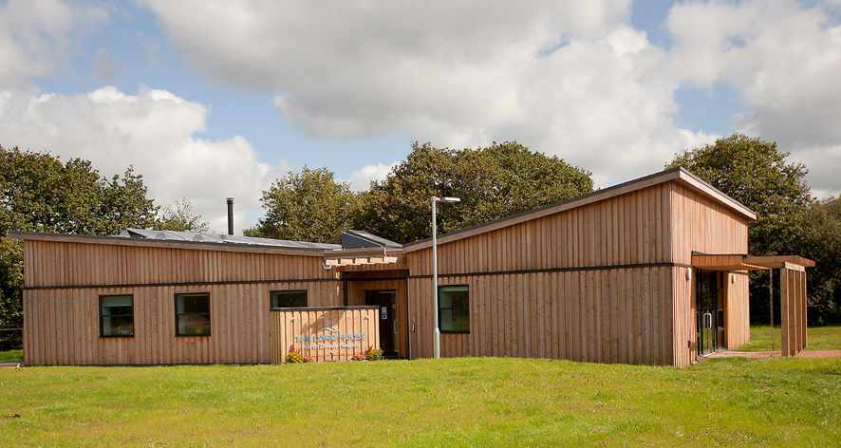

North Devon Hospice’s The Long House Outreach centre in Holsworthy

Job Description

Job title Consultant in Palliative Medicine
Reporting to
- Chief Executive, North Devon Hospice
- Medical Director of Northern Devon Healthcare Trust (NDHT)
- Responsible Officer is the Deputy Medical Director at NDHT.
- Direct line manager at NDHT is Lindsay Stanbury, Group Services Manager
Programmed 8 Programmed Activities (PAs) (5.5 Direct Clinical Care, 2.5
Activities Supporting Professional Activities) This is an indicative programme and the actual SPA allocation will be subject to review as part of annual job planning, and dependent on responsibilities and service developments, etc.

On-Call: Category B, 2nd On-call to Hospice Medical Officers

Location: Main base will be North Devon Hospice, Barnstaple but in addition NDDH and in the community

Key responsibilities
- Palliative Medicine Consultant to North Devon Hospice including community team and 7 Bedded Unit
- Palliative Medicine Consultant support and input to NDDH Supportive and Palliative Care Team, including cover for planned absences of consultant colleague

Other responsibilities
- Chair weekly Specialist Palliative Care MDT meetings
- Facilitator of complex case review meetings and education meetings for Clinical Nurse Specialists
- Facilitator of reflective learning sessions for Hospice teams .
- Attendance at the quarterly Care Quality Working Group meetings
- Member of Northern Locality Accountable Care Group for End of life Care
- Member of NDHT EoL Steering Group
- Member of Senior Management Team for NDHT Supportive & Palliative Care Team

Hospital Role
There is a part-time Palliative Medicine Consultant based at NDDH (6 PA). Their job plan has been designed in conjunction to this role’s job plan to ensure effective coverage across all sites at all times. When a consultant is not on-site, either hospice or hospital medical staff can contact the consultant for advice by telephone in working hours (or attendance to either site by exception, as required).

The postholder will attend NDDH’s weekly Specialist Palliative Care MDT meeting. They will also have opportunity to attend site-specific Cancer MDT meetings and other hospital meetings according to their areas of interest, as outlined earlier.

In addition to the above and in recognition of the formal collaboration between Northern Devon Healthcare Trust and Royal Devon & Exeter Foundation Trust (RD&E) there is a peer support network with the Palliative Consultant team at RD&E. Opportunities also exist to join Palliative Medicine Consultant education sessions of Somerset Partnership colleagues too.

Out of Hours duties
Consultant on-call commitments are currently being re-designed following retirement of the current postholder. Consultants will provide second on-call cover to North Devon Hospice. Its out-of-hours rota of first on-call doctors comprises experienced regular and bank Medical Officers, who perform ward rounds on weekends and public holidays.

The Consultant on-call will be non-residential, and predominantly expected to give telephone advice only. Only in exceptional circumstances would they be expected to attend the Hospice in person.

Due to the number of PAs and the fact that there is no weekend working, time off in-lieu will not routinely be provided. On call commitments will be renumerated in accordance with banding in NHS consultant contract.

Once this vacancy is filled the post-holder and the hospital based consultant will both contribute equally to the on-call rota. We are currently working with organisations and consultants beyond North Devon to achieve our long-term vision: a rota with on call frequency of 1 in 4 weeks or less frequent to ensure a sustainable model for the future.

Management and Leadership
- As a medical lead of the Senior Management Team of North Devon Hospice, contribute to the strategic shaping of the organisation, ensuring that hospice services develop and integrate with existing and future provision of palliative care.
- Work with NHS Devon, Clinical Commissioning Groups, Sustainability & Transformation Partnership, GPs (Consortia), the Northern Devon Healthcare Trust (NDHT) and other healthcare professionals to build on the existing relationships across all areas of palliative medicine to best position North Devon Hospice.
- Develop a holistic and integrated palliative medicine service across North Devon that challenges the boundaries and perceptions of palliative care.
- Act in a manner at all times to safeguard the interests of individual patients/clients and their families and justify public trust and confidence in North Devon Hospice.
- Attend meetings of the Board of Trustees of North Devon Hospice and sub-committees as and when requird to report and recommend to Trustees on issues relating to the effective delivery of care services and educational activities.
- Represent the hospice by participating in planning and service development with senior managers in NHS Devon, NDHT and other organisations as required.
- Provide line management to the Medical Officer team at North Devon Hospice covering the 7 Bedded Unit and a Medical Secretary.

Professional and Patient Care
- To ensure the provision of outstanding clinical care
- Work with the Director of Care to ensure compliance with all aspects of North Devon Hospice’s registration requirements with the Care Quality Commission. Providing close liaison with the Care Quality Commission, the Chief Executive, Corporate Governance Committee and the Board of Trustees.
- In consultation with the Director of Care develop and implement new policies and procedures as required by the Care Quality Commission, or to meet operational need, as appropriate.
- As a member of the multidisciplinary team promote and demonstrate a culture of continuous improvement to ensure that the highest standards of patient care are maintained.
- Develop and lead the hospice so that it can demonstrate and evidence the quality and equity of service provision, thereby identifying and addressing gaps in service provision.
- Ensure compliance with Health and Safety at Work Act requirements for care staff, patients and visitors both at North Devon Hospice and at North Devon District Hospital.
- Active member of the Care Quality Working Group at North Devon Hospice.
- As a member of the South West Palliative Care Consultant Network, participate in regular meetings with this peer group.

Clinical Education
- Support the Director of Care in determining a future education provision strategy for the hospice.
- Support the Clinical Educator in delivering a dynamic and forward thinking education programme across North Devon and across the Peninsula.
- In conjunction with the Clinical Educator, participate in the organisation and delivery of education programmes for hospice staff and external stakeholders.
- Participate in teaching other groups outside the Hospice as appropriate, including healthcare professionals of various disciplines at NDHT

Supporting professional activities
You will be expected to participate in a variety of professional activities (SPA) to support your personal clinical practice and the overall work of the department and Trust. This
includes, but is not limited to:

- Appraisal, job planning and revalidation
- Personal and professional development, including service development and your own CPD
- Professional administration, including related correspondence
- Governance and quality improvement activities including active participation in medical audits

This job description is intended to provide an outline of the duties and responsibilities of this post and may change periodically following discussions between the Chief Executive, Trust Line Manager and the post-holder.
Provisional Job Plan

A provisional outline job plan is below but is subject to modification. The individual job plan and detailed timetable will be discussed with the successful candidate. Special interests will be accommodated unless this is incompatible with service requirements.

Provisional Timetable
 | Morning 9-1 | Afternoon 1-5 | DCC | SPA
Monday | Bedded Unit Ward Round  (Up to 7 In-Patients)  9-1 (1PA) | NDDH clinical support 1-3 (0.5PA)  SPA 3-5 (0.5PA) | 1.5 | 0.5
Tuesday | Hospice MDT  9-11 (0.5PA)  team education/admin  11-1 (0.5 SPA) | Community Team  (Up to 3 slots for outpatients or home visits)  1-5 (1PA) | 1.5 | 0.5
Wednesday | Non-working day | Non-working day
Thursday | Hospice clinical support (Bedded Unit and/or Community Team)  9-1 (1PA) | NDDH MDT meeting  1-2 (0.25PA)  SPA – including weekly meeting with Consultant colleague  2-4 (0.5 SPA)  Admin 4-5 (0.25 SPA) | 1.25 | 0.75
Friday | NDDH  (Clinical Support usually seeing up to 4 patients with CNS)  9-1 (1PA) | SPA 1-4 (0.75 SPA) – to include flexible 2hrs/0.5 SPA for SMT activity)  Clinical troubleshooting  4-5 (0.25PA) | 1.25 | 0.75
Total sessions |  |  | 5.5 | 2.5

Person Specification

Qualifications and Training | Essential or Desirable
Primary Medical Qualification (MBBS or equivalent) | E
Full GMC registration and licence to practice. | E
Membership of MRCP (UK) or equivalent | E
Eligible to work in the UK | E
Entry on the GMC Specialist Register via one of the following:  a. Certificate of Completion of Training (CCT) (the proposed CCT date must be within 6 months of the interview)  b. Certificate of Eligibility for Specialist Registration (CESR) | E
Additional postgraduate qualifications. | D
Distinctions, Prizes, Scholarships. | D
Clinical Experience
Be able to provide complete details of employment history. | E
Career progression consistent with personal circumstances. | E
Experience in Palliative Medicine. | E
Experience of working in the hospice sector | D
Ability to take full and independent responsibility for clinical diagnosis and patient care. | E
Demonstrates a clear, logical approach to clinical problems and an appropriate level of clinical knowledge. | E
Able to prioritise clinical need. | E
Demonstrates awareness of breadth of clinical issues. | E
Further sub-speciality experience (e.g. Fellowship post) | D
Non-Clinical skills
Enthusiasm for teaching and training. | E
Demonstrates clear understanding of quality improvement and clinical governance within healthcare settings. | E
Demonstrates willingness to implement evidence-based practice. | E
Evidence of effective personal contributions to clinical audit, governance and risk reduction. | E
Understanding of the principles of scientific method and interpretation of medical literature. | E
Demonstrates a critical and enquiring approach to knowledge acquisition. | E
Good spoken and written English language skills. | E
Communicates effectively with patients, relatives, colleagues, nurses, and allied health professionals. | E
Evidence of ability to work with multi-professional teams and to establish good professional relationships. | E
Information technology skills. | E
Caring attitude to patients. | E
Defined educational roles or qualifications. | D
Experience of change management | D
Evidence of contribution to Departmental/Trust/Regional teaching programmes. | D
Evidence of innovative development and implementation of guidance. | D
Evidence of involving patients in practice development. | D
Evidence of relevant research, presentations or publications. | D
Evidence of patient and colleague feedback. | D
Excellent presentation skills, engages audience. | D
Other Requirements
Compassionate, positive and empathetic | E
Good personal organisational and prioritisation skills. | E
Takes responsibility for personal practice and is able to cope well with stressful situations. | E
Commitment to continuing medical education and professional development. | E
Full UK driving license and ability to travel independently to perform home visits | E
Demonstrates initiative in personal practice. | D
Willingness to undertake additional professional responsibilities at local level. | D
Creative, energetic and resourceful with the ability to influence | D
A high degree of personal integrity, honesty and openness | E

Key E Essential D Desirable

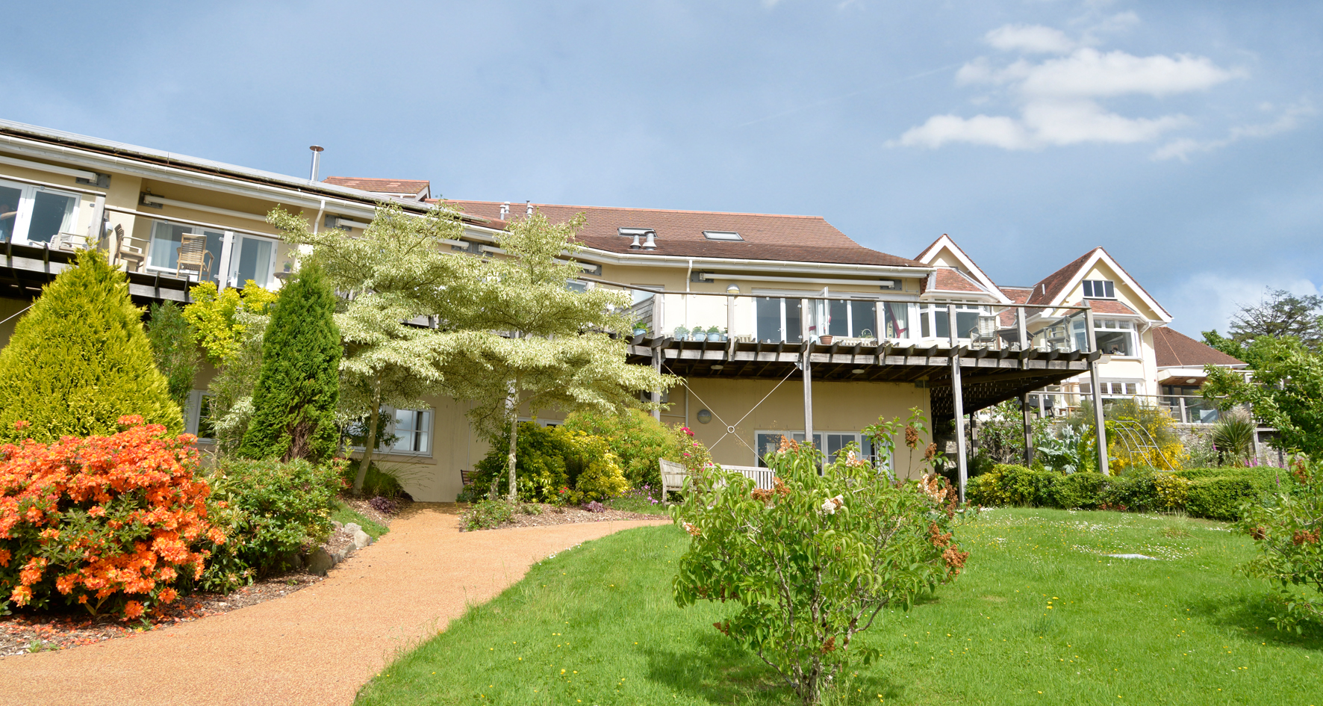
Deer Park, Barnstaple, home to North Devon Hospice

Terms & Conditions

The employer is Northern Devon Healthcare NHS Trust. The appointee will participate in the NDHT appraisal and revalidation process as well as having an annual hospice review carried out by the Chief Executive. The post holder is accountable to NDHT’s Responsible Officer for revalidation purposes. The post holder is required to have full registration with a licence to practice with the General Medical Council and to ensure that such registration is maintained for the duration of the appointment.
Appointment is to the NHS Consultant Contract (2003) under the current Terms
Conditions of Service for Hospital Medical and Dental Staff (England and Wales) and the Conditions of Service determined by the General Whitley Council for the Health Services
(Great Britain). These are nationally agreed and may be amended or modified from time to time by either national agreement or local negotiation with the BMA local negotiating committee.

Salary This is as described in the Medical and Dental Terms and Conditions, in line with the Consultant Contract (2003). The current full time salary scale (as at August 2019) ranges £77,913 to £105,042 with eight thresholds.

Leave As described in Schedule 18 of the Terms and Conditions of Service: Consultant (England) 2003.
Study leave entitlement is 33 days over a fixed three year period.
Locum cover for leave will not normally be provided. It is expected that you will co-ordinate leave with your palliative care consultant colleague based at NDDH.
Domicile Consultants are expected to reside within a reasonable distance of North Devon. Exceptions must be agreed with the Chief Executive.
A £5k relocation package may be considered if relocation is necessary to meet these requirements.
Mentoring New consultants will have access to mentoring and are encouraged to take advantage of this facility. This will be arranged following discussion and mutual agreement between the individual and their Line Manager in NDHT.
Research
& Audit Audit is supported by the Clinical Audit and Effectiveness department and we encourage all levels of staff to undertake quality improvement projects.

Location Deer Park, Barnstaple, EX32 0HU but expected to work in the community across North Devon and at North Devon District Hospital. On days when travelling between hospital and hospice the journey time is typically 12mins by car.
Notice 3 months
Why North Devon?

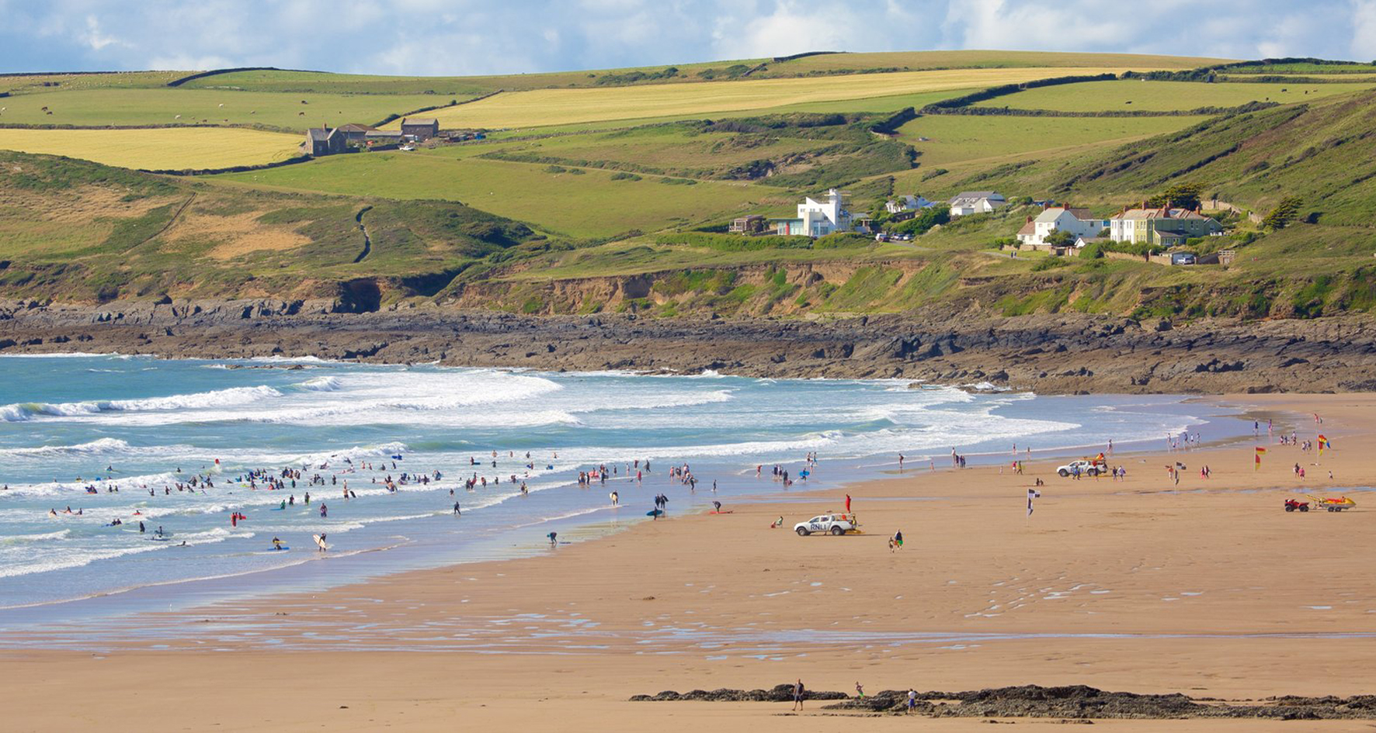 | The Beaches: Croyde, Saunton Sands, Putsborough and Westward Ho! whether surfing, dog walking or just sitting! North Devon is blessed with some of the largest and unspoilt beaches in the UK. This includes Woolacombe which was voted as one of the best beaches in the world.
 | The Food: From Michelin star restaurants, cosy country pubs or contemporary cocktail bars, North Devon makes full use of its plethora of local produce to meet the needs of any foody!
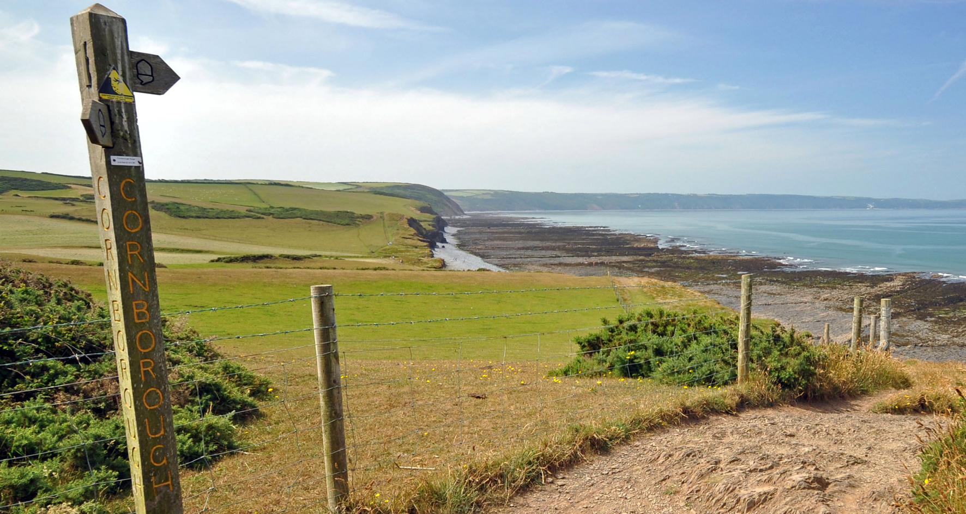 | The Walks: From sharing a path with wild ponies on Exmoor to the stunning coastal pathway North Devon is a walker’s paradise. North Devon has several areas of Outstanding Natural beauty as well as Lundy Island on our door step.
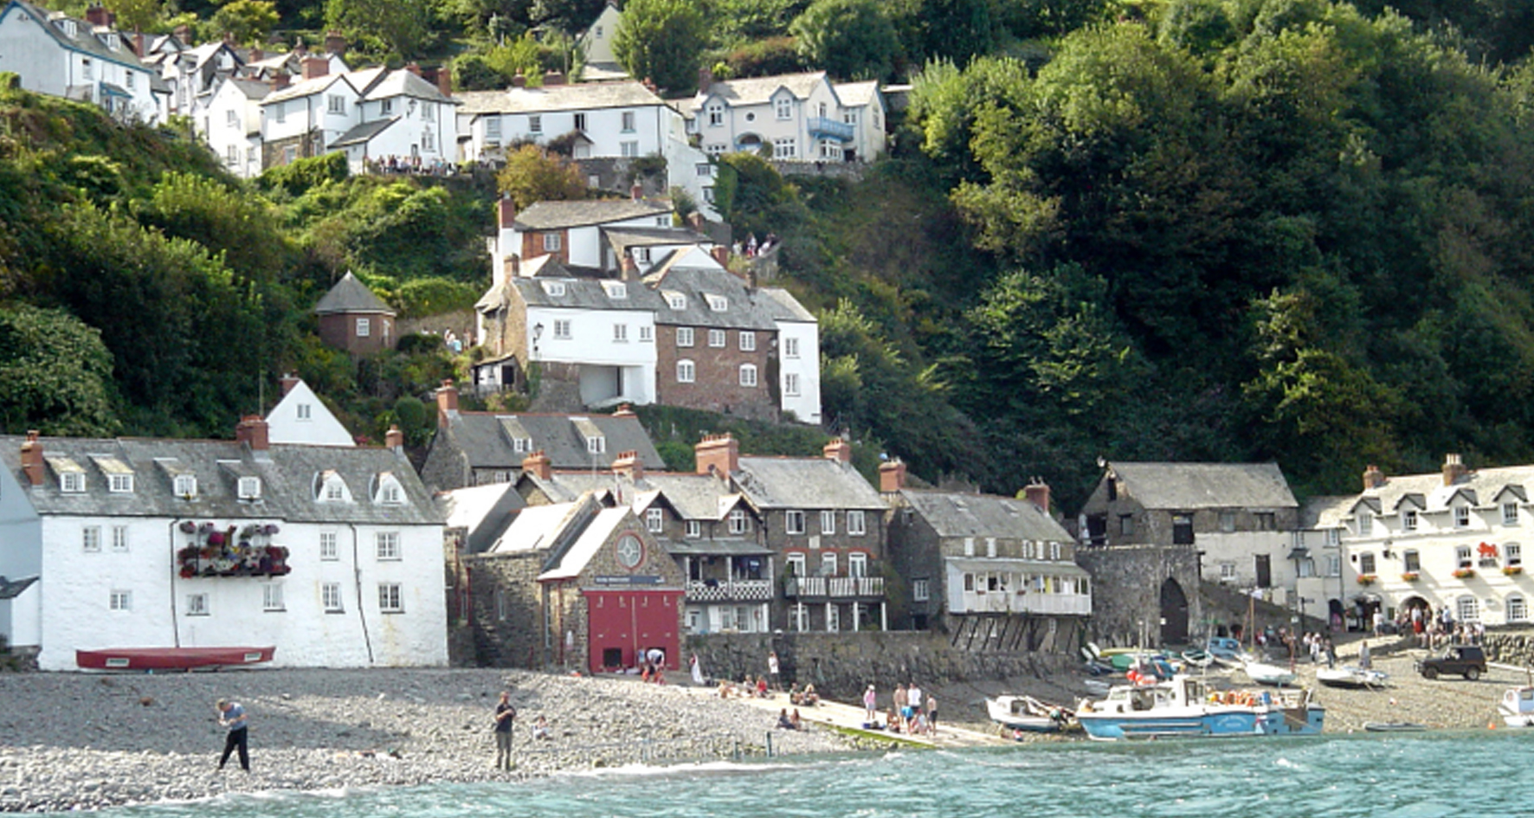 | The Attractions: RHS Rosemoor, Dartington Crystal, Zooes, too many gardens to list, a Wildlife Park, a Wake Park, an adventure centre, Clovelly village, honey farm, aquarium and family entertainment including The Big Sheep, Watermouth Castle, The Milkyway. You won’t get bored!
How To Apply

Please apply online via the NHS Jobs website.
Both the Hospice and Trust actively welcome informal enquiries and visits from interested applicants. Below is a list of individuals whom you may wish to contact for more information.

Mr Stephen Roberts, Chief Executive, North Devon Hospice
Secretary: 01271 347 239
Email: stephenroberts@northdevonhospice.org.uk

Dr Hasib Choudhury, Consultant in Palliative Medicine, Northern Devon Healthcare NHS Trust
Secretary: 01271 311 642
Email: h.choudhury@nhs.net

Sharon Hinsley, Associate Director of Operations–Unscheduled Care, Northern Devon Healthcare NHS Trust
Secretary: 01271 322406 (ext 2406)
Email:sharon.hinsley@nhs.net

For further exciting information about living and working in North Devon, including interviews with current Consultants, please visit the recruitment website: http://www.ndhtjobs.com/

