Retail Assistant Volunteer
Role Description

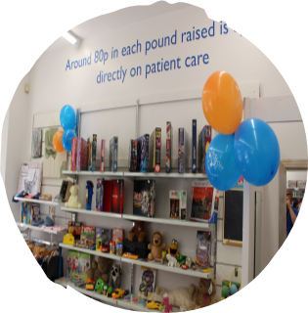
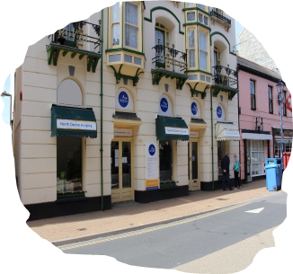

The aim of the role:
North Devon Hospice has a network of charity shops across North Devon raising essential funds so that the hospice can continue providing care and support locally. Our retail team provide a warm, friendly and welcoming environment for our customers whether they are in one of our retail outlets, in the warehouse or on the phone. Our retail volunteers support the shop manager with the day to day running of the shop and are ambassadors for the hospice.

What’s involved:
Great customer service, ensuring our customer are made to feel welcome and are offered any help and advice as required. Processing sales and taking payments using the electronic till system and ensuring donations and customers are dealt with in a polite and friendly manner. Assisting staff where directed and always maintaining a clean and safe environment. You will also support staff in maintaining security of the shop and to be an ambassador for the hospice at all times. Undertaking any other tasks as requested or appropriate within the nature of the role. A taster session will be arranged to ensure you understand what your role would entail.

Hours required:
We currently require cover for two shifts, either mornings 9.15am - 12:30pm or afternoons 12:15pm – 4pm days to be confirmed with line manager. Commitment to a regular shift, or shifts, per week is preferable.

What the hospice offers:
♦ A safe, welcoming and supportive environment
♦ An induction & full training and guidance given on all aspects of the role
♦ Reimbursement of reasonable travel expenses
♦ You will be part of a dedicated and friendly team
♦ The opportunity to utilise existing skills or develop & learn new skills
♦ The opportunity to meet new people
♦ The knowledge you are directly contributing to the care & support offered to our patients and their families we care for

What you can offer us:
♦ An ability to work as part of a team in a busy environment
♦ A friendly, approachable and non-judgemental manner with a good attention to detail
♦ Be able to maintain confidentiality and have an awareness of maintaining boundaries
♦ Good communication skills & an ability to relate to people from all backgrounds
♦ Previous retail experience or an interest in fashion desirable
♦ A willingness to undertake training and to follow NDH policies and guidelines
♦ An agreement to follow all Covid related safety & infection control measures
♦ An adaptability to changing trends and requirements

Next steps:
If you would like to join our Retail team please contact Sue or Sharon in our Volunteering Office. For an informal chat call: 01271 347226 or email volunteering@northdevonhospice.org.uk
Details of this role and all our current vacancies can be found on our website along with our volunteer application and equality monitoring forms, both of which we require completed.
https://www.northdevonhospice.org.uk/jobs-volunteering/working-for-north-devon-hospice/
Please note: a Disclosure and Barring Service check is not required for this role, we will however require two character references.

If you have any questions about this role or any volunteering opportunities with the hospice please contact the Volunteering Office as above.

