A (very) simple guide to drawing a mandala.

You will need pencil, ruler, and either a compass or some plates/lids/dishes of varying sizes, plus whatever you wish to complete the design – felt tips, fine-liners etc. If you are like me then you will need an eraser too! And it helps if your pencil is nice and sharp (mine wasn’t!).

As there are no ‘rules’ to this, you can make your design as big or small as you like and can have as many circles within it as you wish.
It is much easier to create with a compass, but I was quite pleased with my plate/bowl/lid effort!

Start with a centre point.
If you are using a compass the next bit is simple, just create some concentric circles going out from this point.
If you are using things to draw around, and you will need to do some measuring to make sure you are working equally from that centre point.
So you might be aiming for something like this: 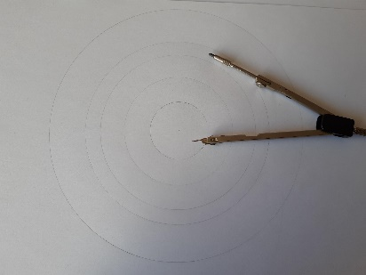
Or a bit more along these lines: 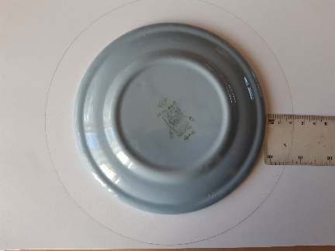, 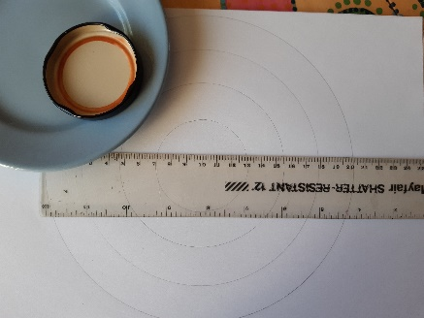.

Once you have the rings, you then need to divide the mandala up into equal (or unequal!) segments. This is to give you the structure on which to create your repetitive design.
Like this: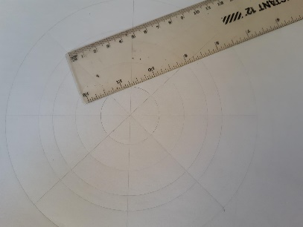 .

There are no rules, so divide into as many segments as you wish, using the ruler to measure so they are equally spaced (if this is what you want). You may want to have a different number of segments on the outer rings than on the inner rings…

Once you are happy with your ‘grid’ you can start adding in patterns. This may be very neat or a bit more doodled. Use the segments to help you repeat your pattern through out each ring.
A tip would be to keep things simple to start with, you can go back and add detail if you want to.
A bit like this (you can see mine is not perfect!): 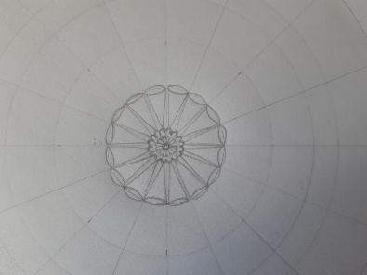

Once you have filled you circle you can go over the lines in pen, colour in, or add further details, as you wish. I might then rub out the pencil scaffolding lines if they are visible.

Enjoy playing. If you want more ideas or advice there is loads of stuff on-line to expand your mandala mindfulness.

