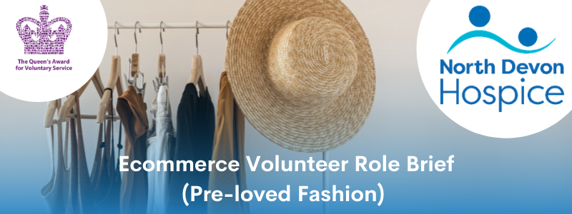

The aim of the role:
Do you have a passion for fashion? The North Devon Hospice Ecommerce Team utilises online selling platforms Depop and eBay to rehome high quality pre-loved clothing. These sales help us raise essential funds to ensure the hospice continues providing care and support for local people who are affected by a life-limiting illness. Our Ecommerce volunteers work alongside us using their skills and experience in identifying, photographing and listing for sale valuable pieces. Our retail team provide a warm, friendly and efficient service for our customers whether they are in one of our retail shops, in the warehouse, online or on the phone and all our volunteers are ambassadors for the hospice.

What’s involved:
We are looking for volunteers who are passionate about pre-loved fashion and would enjoy researching and listing our donated items for sale online. A keen sense of current trends would be beneficial. You will be trained in how best to use online resources to ensure we maximise value for the hospice. A taster session will be arranged to ensure you understand what your role would entail.

Hours required:
We have a variety of shifts available, depending upon your suitability and preference for the tasks to be undertaken. We can often be quite flexible with start and finish times so please contact the Volunteer Office for more details.

A variety of shifts currently available from Monday – Friday
Between 9am and 4pm.
Commitment to a regular shift, or shifts, per week is preferable.
What the hospice offers:
♦ A safe, welcoming and supportive environment
♦ An induction & full training and guidance given on all aspects of the role
♦ We will work with you to ensure you feel confident in every aspect of your role.
♦ Reimbursement of reasonable travel expenses
♦ You will be part of a dedicated and friendly team
♦ The opportunity to utilise existing skills or develop & learn new skills
♦ The opportunity to meet new people
♦ The knowledge you are directly contributing to the care & support offered to our patients and their families we care for
What you can offer us:
♦ An ability to work as part of a team in a busy environment
♦ A friendly, approachable manner, reliable and trustworthy
♦ A willingness to learn
♦ Confidence in using a variety of IT equipment preferred but full training will be given
♦ Be able to maintain confidentiality and have an awareness of maintaining boundaries
♦ Good communication skills with good attention to detail
♦ Previous online retail experience is desirable but not essential
♦ A willingness to undertake training and to follow NDH policies and guidelines
♦ An agreement to follow all Covid related safety & infection control measures
♦ An adaptability to changing trends and requirements
Next steps:
If you would like to join our Ecommerce team please contact our Volunteering Office or download the application documents from our website.
For an informal chat call: 01271 347226 or email volunteering@northdevonhospice.org.uk
Details of this role and all our current vacancies can be found on our website along with our volunteer application and equality monitoring forms, both of which we require completed.
https://www.northdevonhospice.org.uk/jobs-volunteering/working-for-north-devon-hospice/
Please note: a Disclosure and Barring Service check is not required for this role, we will however require two character references.
If you have any questions about this role or any volunteering opportunities with the hospice please contact the Volunteering Office as above.

