Retail Assistant Volunteer
Role Brief

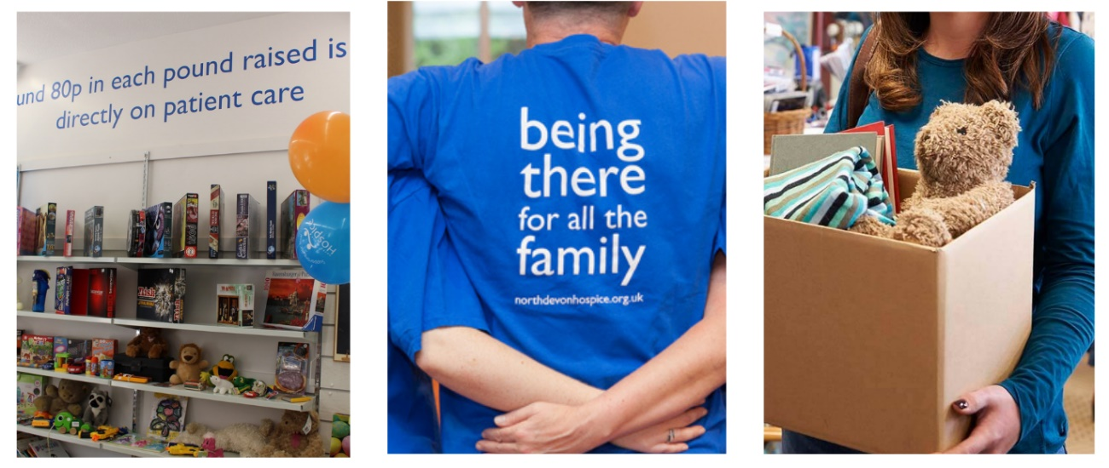

The aim of the role:
North Devon Hospice has a network of charity shops across North Devon raising essential funds so that the hospice can continue providing care and support locally. Our retail team provide a warm, friendly, and welcoming environment for our customers whether they are in one of our retail outlets, in the warehouse or on the phone. Our retail volunteers support the shop manager with the day to day running of the shop and are ambassadors for the hospice.

What’s involved:
Great customer service, ensuring our customer are made to feel welcome and are offered any help and advice as required. Receiving and processing donations, hand steaming clothing, pricing stock, replenishing stock on the shop floor, processing sales and taking payments using the electronic till system. Assisting staff where directed and always maintaining a clean and safe environment and to be an ambassador for the hospice at all times. Undertaking any other tasks as requested or appropriate within the nature of the role.
A taster session will be arranged to ensure you understand what your role would entail.

Hours required:

We have two shifts per day and currently have a number of shifts available, please contact us for details.
Mornings: 9am - 1pm Afternoons: 12:30pm – 4:30pm

Commitment to a regular shift, or shifts, per week is preferable.
What the hospice offers:
“I love the feeling that volunteering gives me - being part of a great team and working towards one goal is really special.”
♦ A safe, welcoming and supportive environment
♦ You will be part of a dedicated and friendly team
♦ An induction & full training and guidance given on all aspects of the role
♦ The opportunity to utilise existing skills or develop and learn new skills
♦ The opportunity to meet new people
♦ Regular social events throughout the year to meet other volunteers and staff across the organisation and to thank you for your contribution
♦ Reward and Recognition Long Service Award for our volunteers
♦ The knowledge you are directly contributing to the care & support offered to our patients and their families we care for
♦ Reimbursement of reasonable travel expenses once agreed in advance

What you can offer us:
♦ An ability to work as part of a team in a busy environment
♦ A friendly, approachable and non-judgemental manner with a good attention to detail
♦ Confidence handling cash/payment cards and processing sales through an electronic till
♦ Be able to maintain confidentiality and have an awareness of maintaining boundaries
♦ Good communication skills & an ability to relate to people from all backgrounds
♦ Previous retail experience is desirable
♦ A willingness to undertake training and to follow NDH policies and guidelines
♦ An agreement to follow all safety & infection control measures
♦ An adaptability to changing trends and requirements

Next steps:
If you would like to join our Retail team, please pop into one of our shops and speak to a member of staff or contact our Volunteering Office.
For an informal chat call: 01271 347226 or email volunteering@northdevonhospice.org.uk
Details of this role and all our current vacancies can be found on our website:
https://www.northdevonhospice.org.uk/jobs-volunteering/working-for-north-devon-hospice/
Please note: a Disclosure and Barring Service check is not required for this role; we will however require two-character references.
If you have any questions about this role or any volunteering opportunities with the hospice,
please contact the Volunteering Office as above

